FitSense - Personalized Fitness Recommendations Powered by AI

PROJECT REPORT

Project Title: AI Fit-Track API
Team ID: SWTID-2026-6076
Team Leader

NAME | EMAIL ID
Rubitha B | rubitha2606@gmail.com
Team Members

NAME | EMAIL ID
Nithish T | nithishvk311@gmail.com
Rajapriyan E | vijayview146@gmail.com
Sabir J | sabir4102006@gmail.com

Project Overview

Purpose

FitTrack AI (FitSense) is a secure, scalable, and AI-powered backend web application developed using Node.js, Express.js, and MongoDB. It provides a RESTful system for workout tracking and intelligent fitness recommendations. The system enables users to create accounts, log in securely, and access protected routes using JSON Web Token (JWT) authentication and bcrypt.js password encryption. It supports complete CRUD functionality for managing workout records and integrates Google Gemini AI to offer personalized workout plans and performance insights based on individual user parameters and workout statistics.

Key Objectives

- Provide secure JWT-based user authentication and authorization for protected REST API access.
- Enable efficient workout management through RESTful CRUD operations (Add, View, Update, Delete, Search).
- Ensure user-specific data isolation so each authenticated user can manage only their own workout records.
- Integrate Google Gemini AI to deliver personalized workout recommendations and performance insights based on user activity.
- Implement a modular Model-View-Controller (MVC) software architecture using Node.js, Express.js, and MongoDB via Mongoose.
- Deliver fast, reliable API responses with standardized JSON outputs, robust validation, and centralized error handling.

Target Audience

- Fitness Enthusiasts: Individuals seeking a centralized system to log daily exercise, monitor activity history, and calculate metrics automatically.
- Beginners & Intermediate Lifters: Users seeking personalized exercise recommendations, weekly schedules, and safety tips tailored to their age, goals, and experience level.
- Data-Driven Athletes: Users looking for automated analysis of their workout statistics (total workouts, average duration, calories burned).

- Mobile & Frontend Developers: Application developers need a secure, standardized RESTful API backend to integrate into web or mobile user interfaces.

Project Architecture
The FitTrack AI backend follows a layered Model-View-Controller (MVC) architecture pattern. Separation of concerns ensures high modularity, maintainability, and scalability.

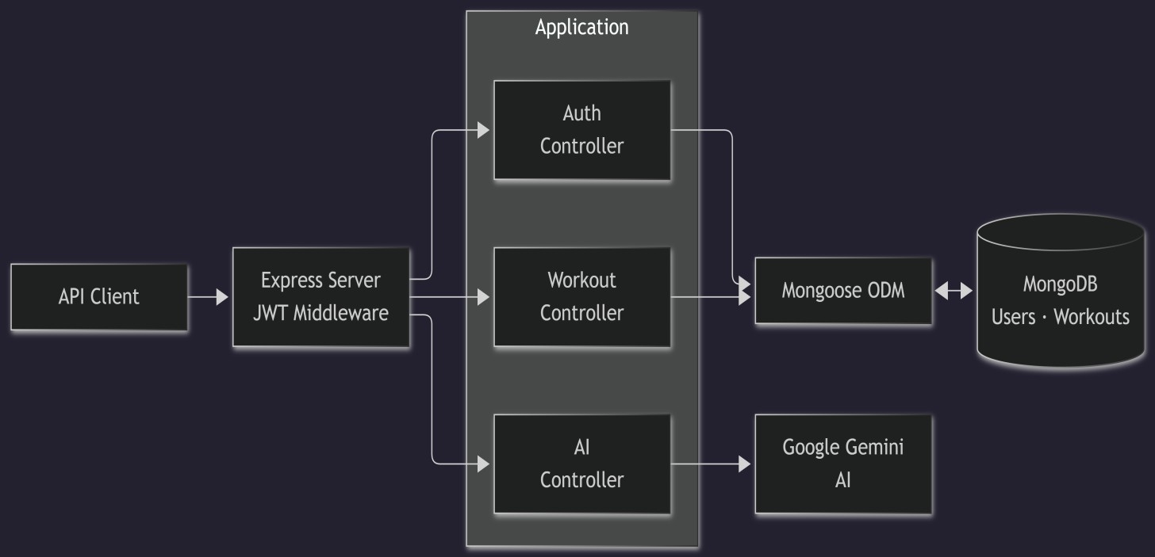

Express Server Gateway

The Express server acts as the central entry point of the application. It starts the HTTP server, handles JSON body parsing, enables Cross-Origin Resource Sharing (CORS), mounts router files, and processes centralized server errors.

Auth Middleware

The Auth Middleware shields protected routes. It intercepts incoming requests, extracts the JWT token from the HTTP Authorization header, verifies the token cryptographic signature, decodes user credentials, and attaches the user's payload to the request before allowing access to controllers.

Auth Controller

The Auth Controller processes user identity logic. It validates input payloads for registration and login, hashes passwords using bcrypt.js, checks credentials against MongoDB records, and issues stateless JWT tokens upon successful authentication.

Workout Controller

The Workout Controller handles core fitness tracking logic. It processes requests to create workout entries, retrieve personal logs, update exercise details, remove records, and execute search filters across workout names, categories, and dates.

AI Controller & Service Layer

The AI Controller communicates with the dedicated Gemini AI service. It constructs structured prompts containing user parameters (age, fitness goal, experience level) or exercise statistics (total workouts, average duration, calories burned) and sends them to Google Gemini AI to return structured recommendations and progress insights.

MongoDB Database

MongoDB is a document NoSQL engine used for persistent storage. Data is stored across two primary collections: Users and Workouts. Mongoose serves as the Object Data Modeling (ODM) layer, providing strict schema definitions, data validation, pre-save hooks, and model operations.

Technical Architecture Summary

- Backend Framework: Node.js, Express.js
- Database & ODM: MongoDB, Mongoose
- Security & Auth: JSON Web Tokens (JWT), bcrypt.js
- External Integration: Google Gemini AI SDK / API

Collections:
  - Users Collection:
    - _id
    - name
    - email
    - password
    - createdAt

    - updatedAt
  - Workouts Collection:
    - _id,
    - user (ref: User),
    - workoutName,
    - category,
    - duration,
    - caloriesBurned,
    - workoutDate,
    - createdAt,
    - UpdatedAt
- Relationship: One User- Many Workouts

Entity-Relationship (ER) Diagram

Below is the logical entity relationship representation for the system:
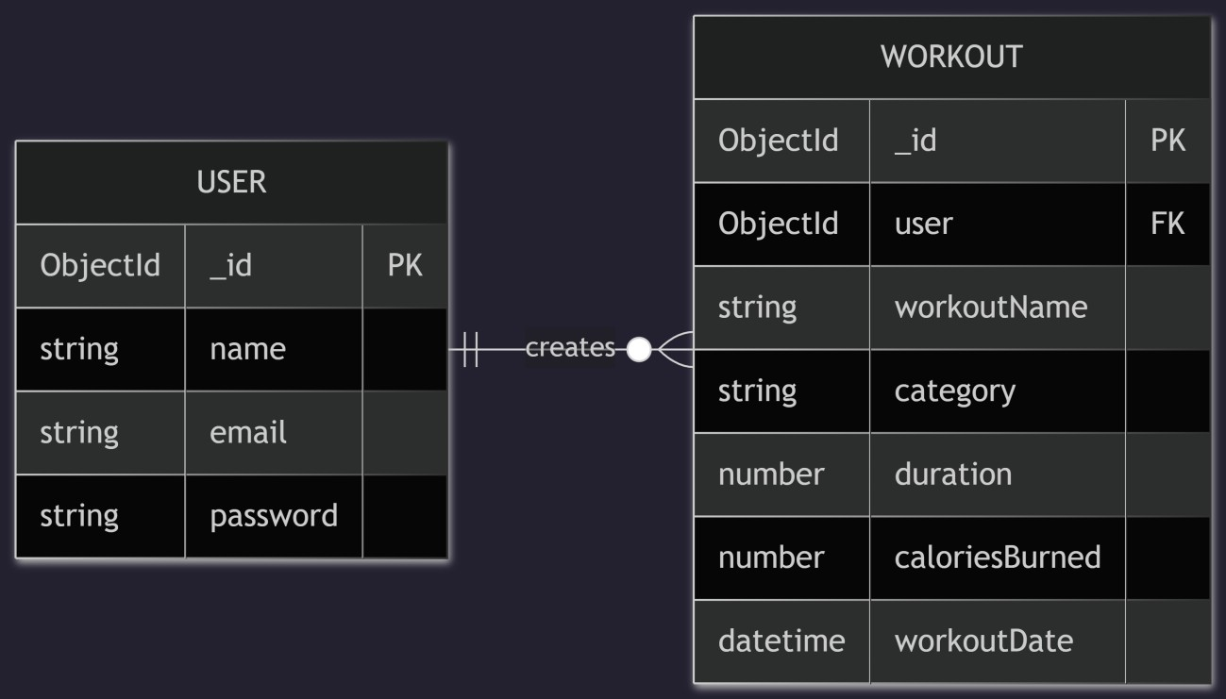

Setup Instructions

Prerequisites

Before setting up the project, ensure that the following tools and technologies are installed on your system:
- Node.js: JavaScript runtime environment.
- MongoDB: Database for storing user data, workout logs, and project records.
- Git: Version control system for cloning and managing code repositories.
- Express.js: Backend framework for handling REST API routing and application server logic.
- Mongoose: Object Data Modeling (ODM) library for MongoDB.
- Visual Studio Code: Recommended Integrated Development Environment (IDE).

Installation Steps

Node.js Setup

      - Knowledge Requirements: Basic JavaScript (variables, functions, promises/async-await), terminal/PowerShell command-line operations, JSON format, and basic Git commands.
      - System Requirements: Windows, macOS, or Linux (x64/arm64); minimum 2 GB RAM recommended; active internet connection.
      - Development Tools: Command terminal (CMD, PowerShell, or WSL on Windows; Terminal on macOS/Linux) and Visual Studio Code.

Standard Installation (Official Windows MSI)

- Download the latest LTS release .msi installer from the official Node.js website.
- Run the installer, accepting default configurations (automatically install node, npm, and configures PATH variables).
- Verify the installation via terminal:

node -v npm -v

Alternative Installation (Version Management via npm-windows)

- Download and run the npm-windows release installer.
- Open an elevated PowerShell or Command Prompt window and run:

npm install lts npm list
npm use lts node -v npm -v

MongoDB Setup

      - Knowledge Prerequisites: Fundamental database concepts (collections, documents, CRUD operations), terminal command usage, and JSON/BSON structures.

System Specifications:
        - OS: Windows (x64/arm64 architecture).
        - Processor: 64-bit, 1 GHz or faster processor.
        - RAM: Minimum 2 GB (4 GB+ recommended for local development).
        - Disk Space: 5–10 GB of free storage space.
        - Port Configuration: Default port 27017 must be available and unblocked by system firewalls.
      - Software Tools: Administrator access, MongoDB Shell (mongosh), and optionally MongoDB Compass (GUI) or Docker for containerized setup.

Git & GitHub Setup

Environment Prerequisites

      - OS & Permissions: Windows OS with Administrator user privileges.
      - Network & Tools: Active internet access for repository actions, Visual Studio Code, and an optional SSH client for secure repository communication.

GitHub Repository Creation Workflow

- Sign in to GitHub: Access GitHub and log in to your account (or register a free account).
- Create Repository: Click the + icon in the top-right toolbar and select New repository.

Configure Project Details:
  - Repository Name: Set a project identifier (e.g., FitTrack-AI-Backend).
  - Description: Optional short project summary.
  - Visibility: Choose Public or Private based on access requirements.
  - Initialization Options: Optionally enable Add a README file, select a Node .gitignore template, and select a software license.
- Finalize: Click Create repository.
- Clone Repository: Copy the HTTPS or SSH clone URL under the Code dropdown button and run the command below in your local terminal:
git clone <repository-url>

Application Setup & Execution

Technical Prerequisites

      - Understanding JavaScript/Node.js, MongoDB database operations, RESTful API endpoint design, and Visual Studio Code navigation.
      - Installed instances of Node.js, npm, and MongoDB (local server instance or MongoDB Atlas connection URI).

Terminal Execution Commands

Run the commands below sequentially in your terminal to initialize the project, install all required dependencies, and start the development server:
Bash
# 1. Clone the project repository git clone <repository-url>

# 2. Navigate to the project root directory cd FitTrack-AI-Backend

# 3. Install client-side dependencies cd client
npm install

# 4. Navigate to the server folder and install backend dependencies cd ../server
npm install

# 5. Launch the Node.js / Express development server npm run dev

Features

Core Features

S.No | Feature | Description
1 | User Authentication | JWT-based account registration and secure login with bcrypt.js password hashing.
2 | Workout CRUD Operations | Complete endpoint support to create, view, update, and delete exercise records.
3 | Workout Search | Route-level filtering of logs by workout name, category, or workout date.
4 | AI Recommendations | Generate personalized plans, weekly schedules, and safety tips using Google Gemini AI.
5 | AI Fitness Insights | Evaluates total workouts, average duration, and calories burned to return progress summaries.
6 | Private Data Security | Middleware enforces token validation and links all records strictly to the logged-in user ID.

Roles and Responsibilities

Authenticated User

- Registration & Login: Register using name, email, and password; log in to retrieve a stateless JWT token.
- Workout Tracking: Add new workouts, review workout logs, update duration/calories, and delete obsolete logs.
- Searching: Filter personal workout logs by name, category, or date.
- AI Interactions: Provide parameters (age, goal, experience) or exercise stats to request AI recommendations and performance insights.

Folder Structure
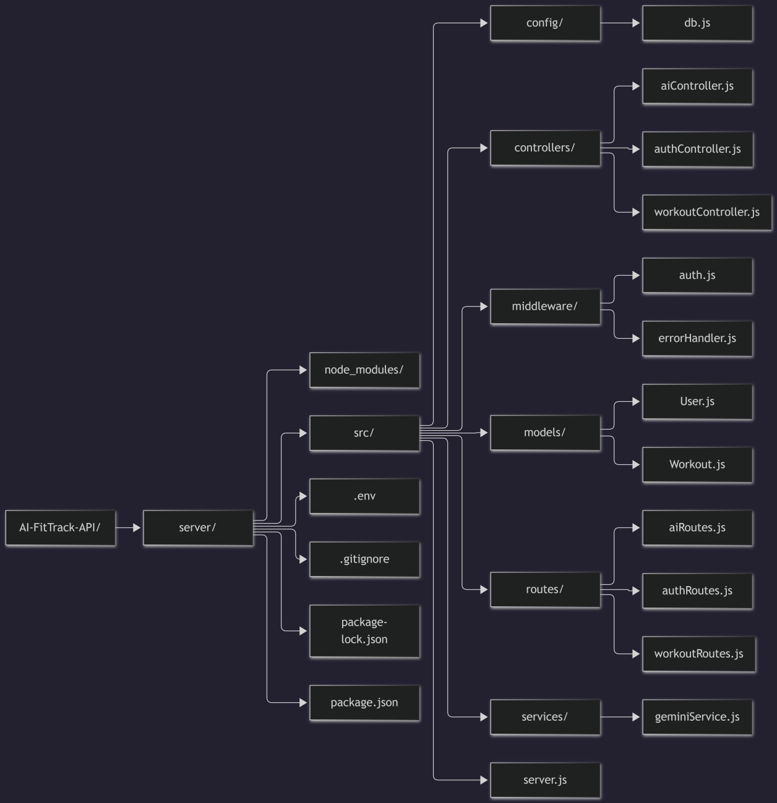

Backend Implementation & Source Code Details

Server & Database Setup

Server Gateway (src/server.js)
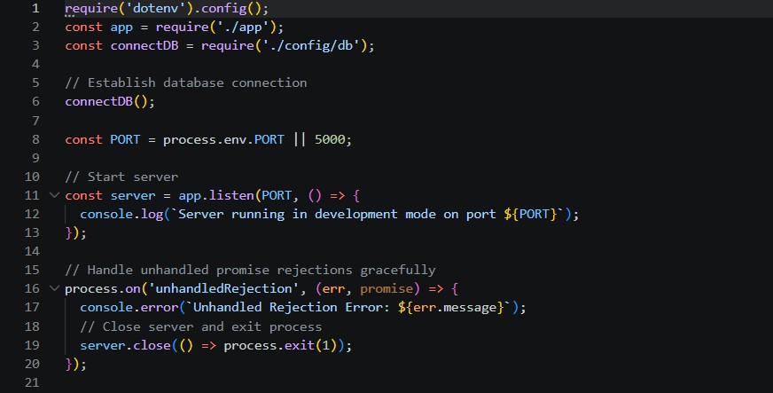

Database Connection (src/config/db.js)
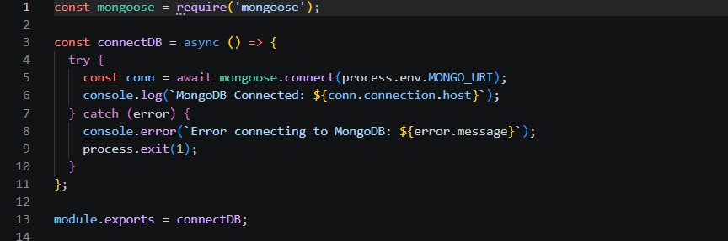

Data Models

User Schema (src/models/User.js)
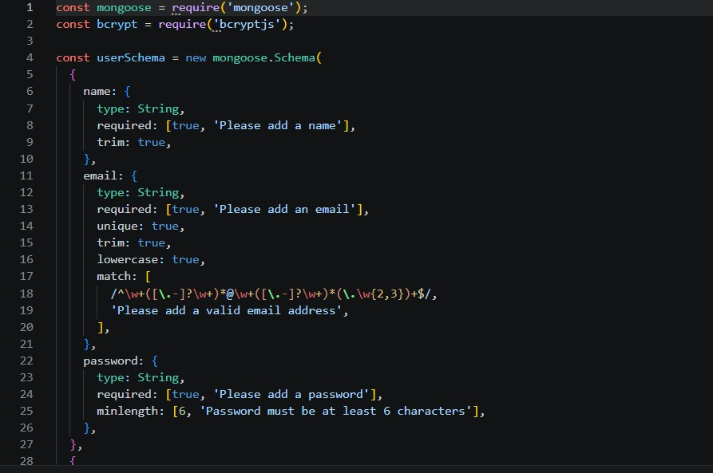
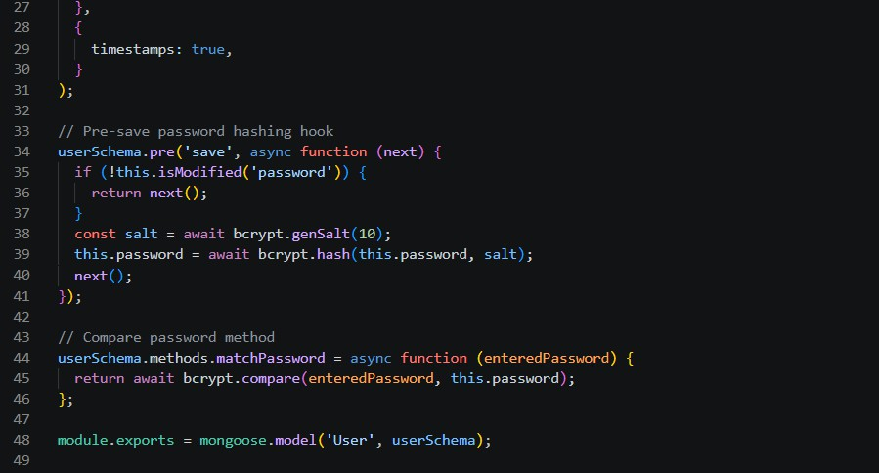

Workout Schema (src/models/Workout.js)
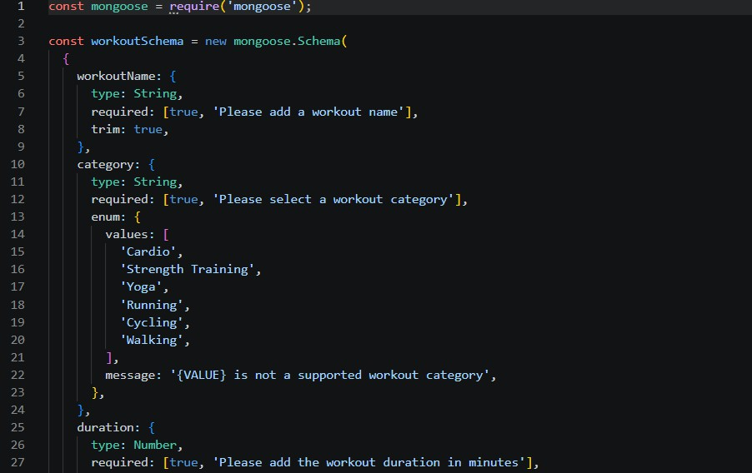
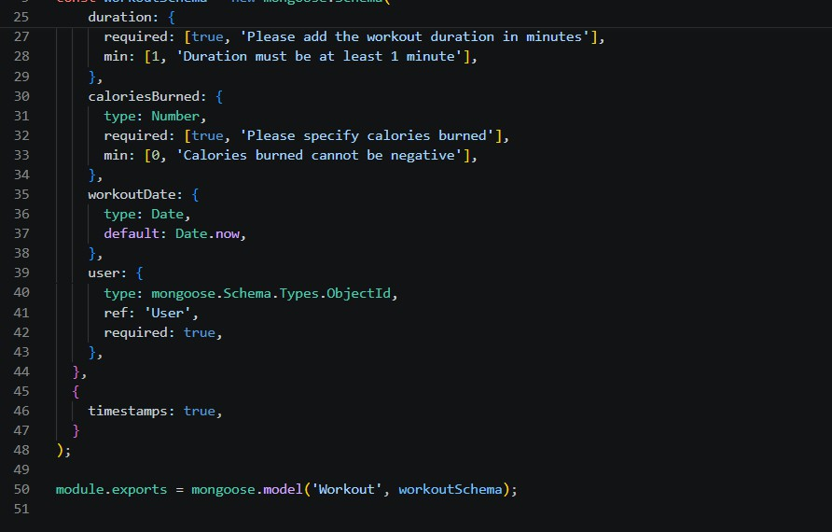

API Testing & Execution Results
Note: Insert screenshots in Microsoft Word at the designated picture placeholders below.

Authentication Endpoints

Register User

  - Method & Route: POST /api/auth/register

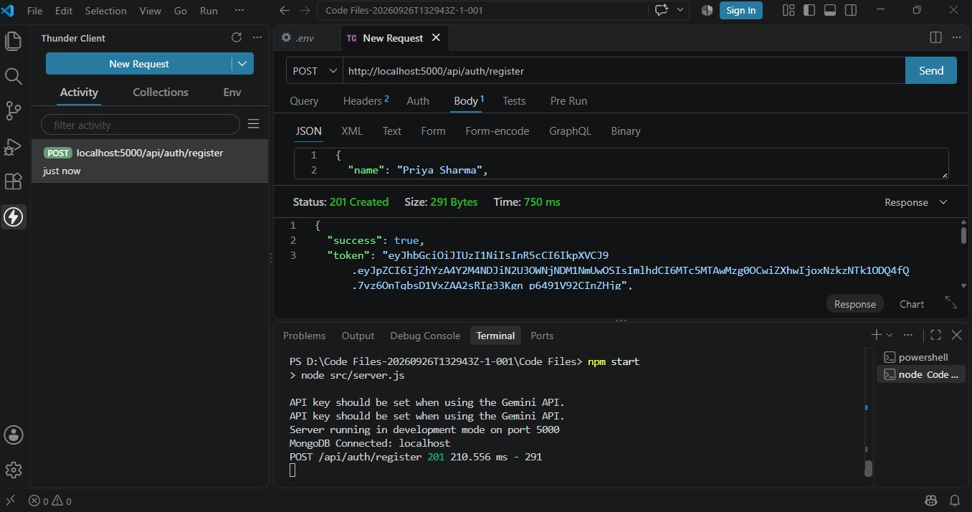

Login User

  - Method & Route: POST /api/auth/login

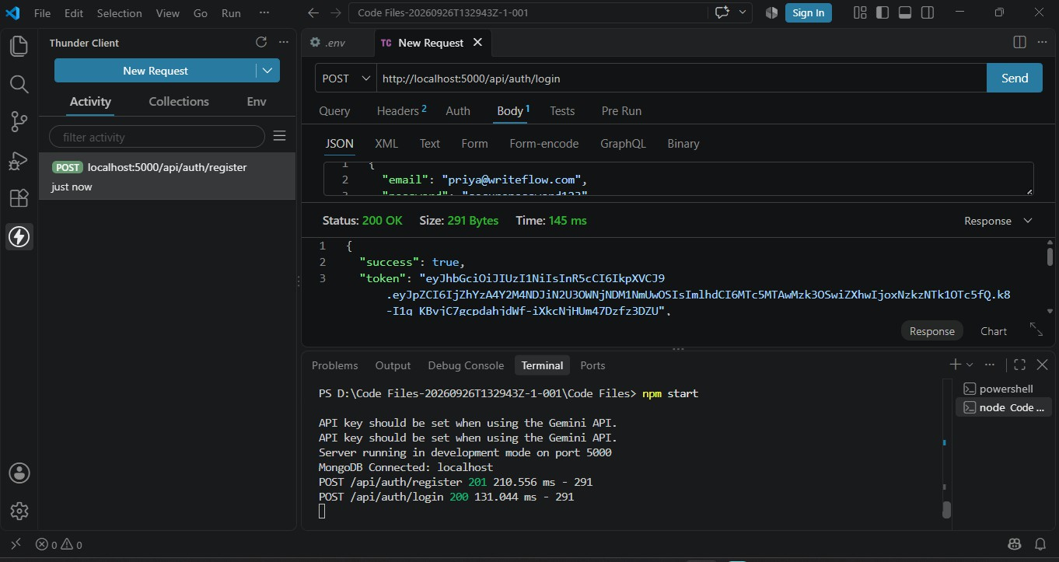

Workout Operations Endpoints

Add Workout Record

  - Method & Route: POST /api/workouts/
  - Headers: Authorization: Bearer <JWT_TOKEN>

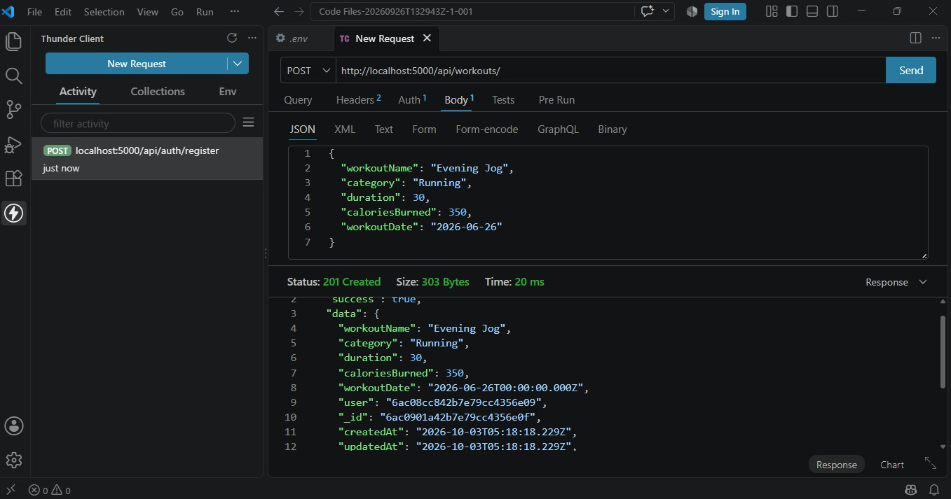

Get All Workouts

  - Method & Route: GET /api/workouts/
  - Headers: Authorization: Bearer <JWT_TOKEN>

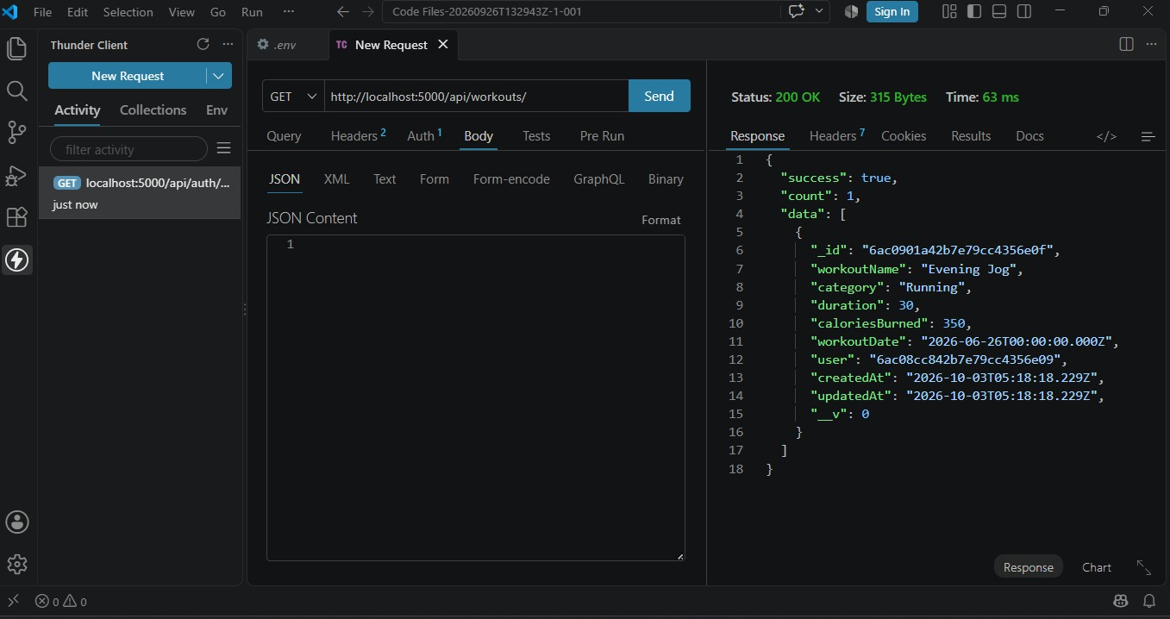

Update Workout

  - Method & Route: PUT /api/workouts/6ac0901a42b7e79cc4356eof
  - Headers: Authorization: Bearer <JWT_TOKEN>

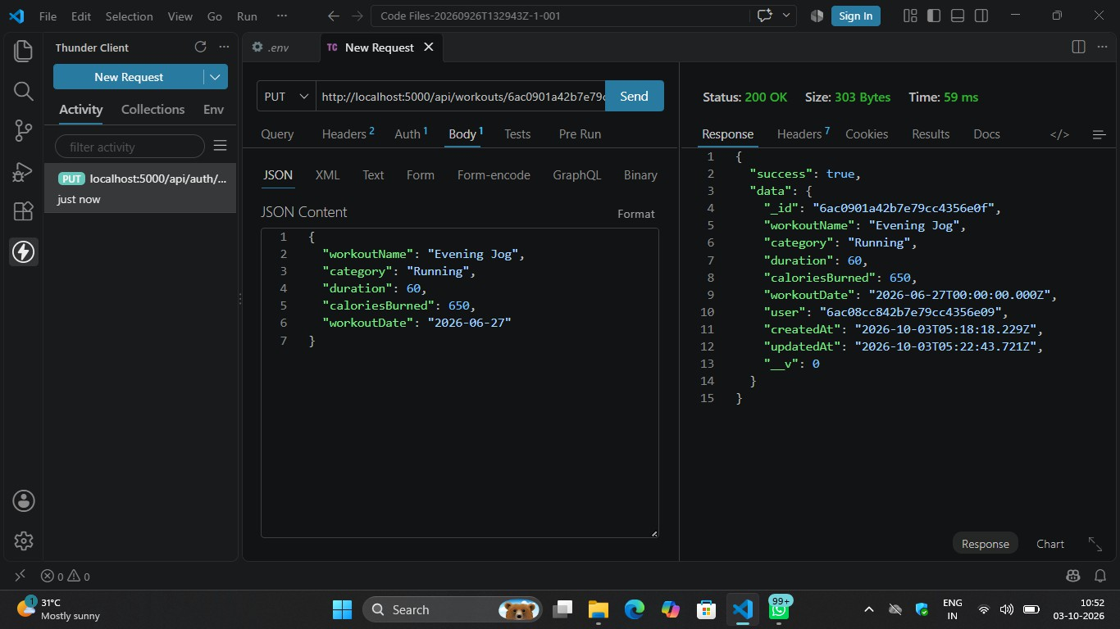

Delete Workout

  - Method & Route: DELETE /api/workouts/6ac0901a42b7e79cc4356eof
  - Headers: Authorization: Bearer <JWT_TOKEN>

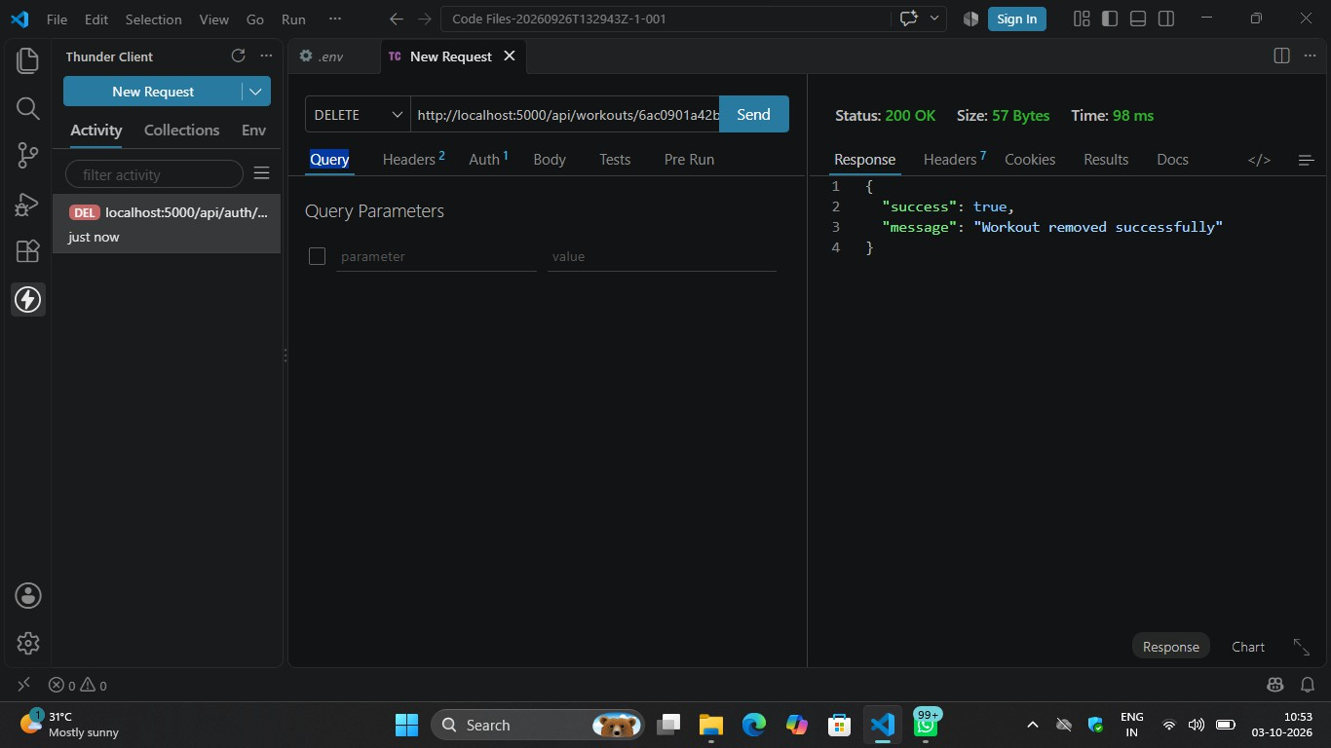

Google Gemini AI Endpoints

Get AI Workout Recommendation

  - Method & Route: POST /api/ai/workout-recommendation
  - Headers: Authorization: Bearer <JWT_TOKEN>

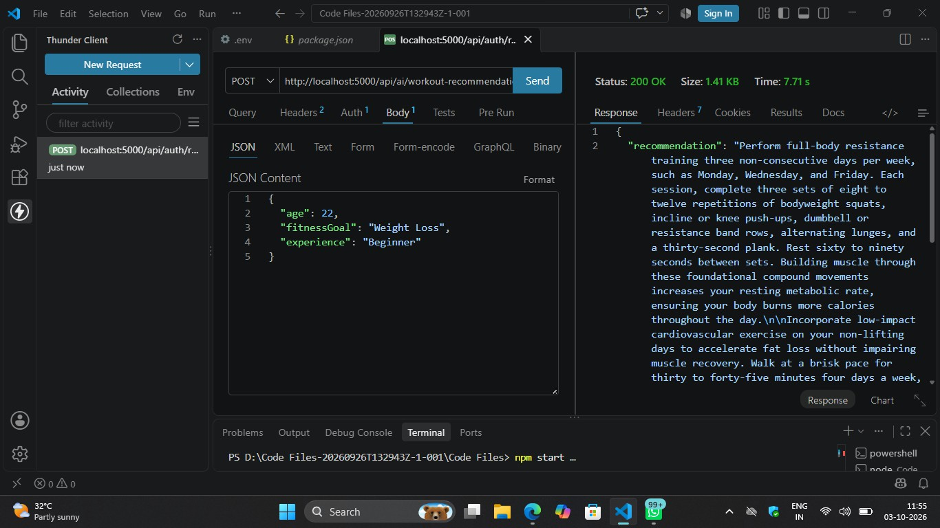

Get AI Fitness Insights

  - Method & Route: POST /api/ai/fitness-insights
  - Headers: Authorization: Bearer <JWT_TOKEN>

